**Allegro Hand V5 ROS1 Demo Manual**

Copyright © WONIK ROBOTICS

**Copyright & Trademark Notice**

Allegro, the Allegro logo and all related files and documentation are Copyright by WONIK ROBOTICS. All rights reserved.

Allegro, Allegro Hand is trademarks of WONIK ROBOTICS. All other trademarks or registered trademarks are the property of their respective owners.

**Contents**

Copyright & Trademark Noice**i**

1. System Requirements**1**

2. CAN Driver Installation**2**

2.1 PEAK PCAN-USB2

3. Using Allegro Hand Demo Program**3**

3.1 Install Demo Program3

3.1.1 3-Finger model3

3.1.2 4-Finger model4

3.1.3 Control more than one hand on 1 PC6

3.2 Set Demo Program6

3.2.1 Sensor - Rviz6

3.2.2 Control with GUI7

**1. System Requirement**

|  |  |
| --- | --- |
| CPU | Intel® CoreTM i3-8109U or higher |
| RAM | at least 2GB |
| Storage | at least 2GB |
| Graphics | OpenGL 3.0 H/W Acceleration enabled with at least 64Mb of video RAM |
| OS | Ubuntu® 18.04 LTS & 20.04 LTS |
| Additional S/W | ROS Melodic & ROS Noetic |

**2. CAN Driver Installation**

**2.1 PEAK PCAN-USB**

PEAK PCAN-USB driver should be installed or plugged in to your computer before installing the proper driver.

CAN Hardware drivers can be downloaded from the respective manufacturer's website. For CAN interface available through WONIK ROBOTICS**,** product driver and documentation are available at the following websites.

Driver Page (Linux):[*https://www.peak-system.com/fileadmin/media/linux/index.php*](https://www.peak-system.com/fileadmin/media/linux/index.php)

Please refer to the following website(s) for instructions on how to set up the CAN device.

CAN Installation (ROS1): <https://www.allegrohand.com/v5-main/4f-ros1-project>

**Note:** Sometimes, the driver may disappear after rebooting the computer. Please check using the *pcaninfo* command, and if it is not found, reinstall the driver using the same method as above.

**2.2 CAN Wiring**

If you want to use CAN communication with the PCAN-USB, connect it to the D-SUB connector as shown in the picture below. Connect the green wire (CAN L) to pin 2 and the yellow wire (CAN H) to pin 7

전자제품, 케이블, 전자 공학, 전기 배선이(가) 표시된 사진

AI가 생성한 콘텐츠는 부정확할 수 있습니다.

**3. Using Allegro Hand Demo Program**

**3.1 Install Demo Program**

There are two folders: one for the 3-finger model and the other for the 4-finger model.

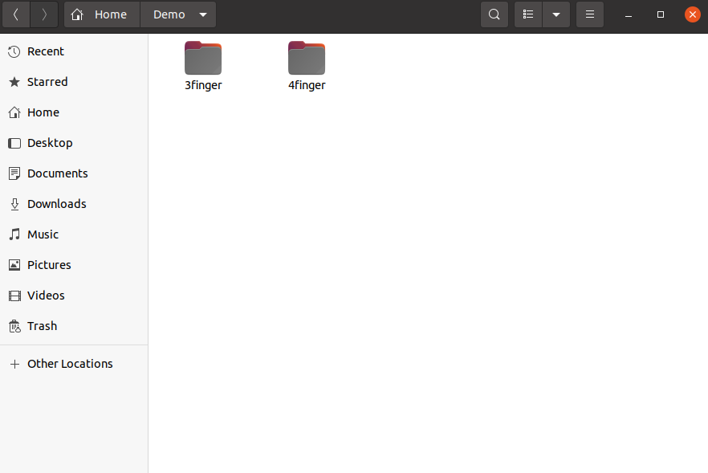

Install Demo Program following the instructions below:

* + 1. **3-Finger model**

1. Install necessary packages.

sudo apt-get update

sudo apt-get install ros-<distro>-visualization-msgs

sudo apt install ros-<distro>-moveit

1. Make your own workspace.

mkdir ~/allegro_ws

1. Copy and paste demo folder in your workspace.
2. Install Bhand library.

cd ~/allegro_ws/3finger/src/bhand

sudo make install

sudo ldconfig

1. Build

cd ~/allegro_ws/3finger

catkin_make

source devel/setup.bash

1. Connect PEAK PCAN-USB and AllegroHand(**make sure to power on Allegro Hand**)
2. Launch ROS DEMO Program.

roslaunch allegro_hand_controllers allegro_hand.launch DEMO:=true GUI:=true

* + 1. **4-Finger model**

1. Install necessary packages.

sudo apt-get update

sudo apt-get install ros-<distro>-visualization-msgs

sudo apt install ros-<distro>-moveit

1. Make your own workspace.

mkdir ~/allegro_ws

1. Copy and paste demo folder in your workspace.
2. Install Bhand library.

cd ~/allegro_ws/4finger/src/bhand

sudo make install

sudo ldconfig

**Note:** For optimal performance, we recommend using one PC to control one hand. However, if that’s not the case and you have already installed a different Bhand library, you must first remove the existing library and then install the one that matches the new finger configuration. The library files and folders from the previous installation can be found on the following path. Make sure to remove all contents from this location:

Bhand folder path: /home/usr/local/include

liBHand.so file path: /home/usr/local/lib

1. Build

cd ~/allegro_ws/4finger

catkin_make

source devel/setup.bash

1. Connect PEAK PCAN-USB and AllegroHand(**make sure to power on Allegro Hand**)
2. Launch ROS DEMO Program.

roslaunch allegro_hand_controllers allegro_hand.launch HAND:=right TYPE:=B DEMO:=true GUI:=true

* + 1. **Control more than one hand on 1 PC**

If you want to control more than one hand on 1 PC, please follow the instructions here:

3-finger: <https://github.com/Wonikrobotics-git/allegro_hand_ros_v5-3Finger>

4-finger: <https://github.com/Wonikrobotics-git/allegro_hand_ros2_v5>

**3.2 Set Demo Program**

Upon launching the ROS demo program, two separate windows are expected to open. These programs were designed based on a 24-inch monitor, so you may need to adjust the window sizes depending on your monitor’s resolution.

**3.2.1 Sensor - Rviz**

This program shows moving Allegro Hand and Sensor data on your screen in real-time.

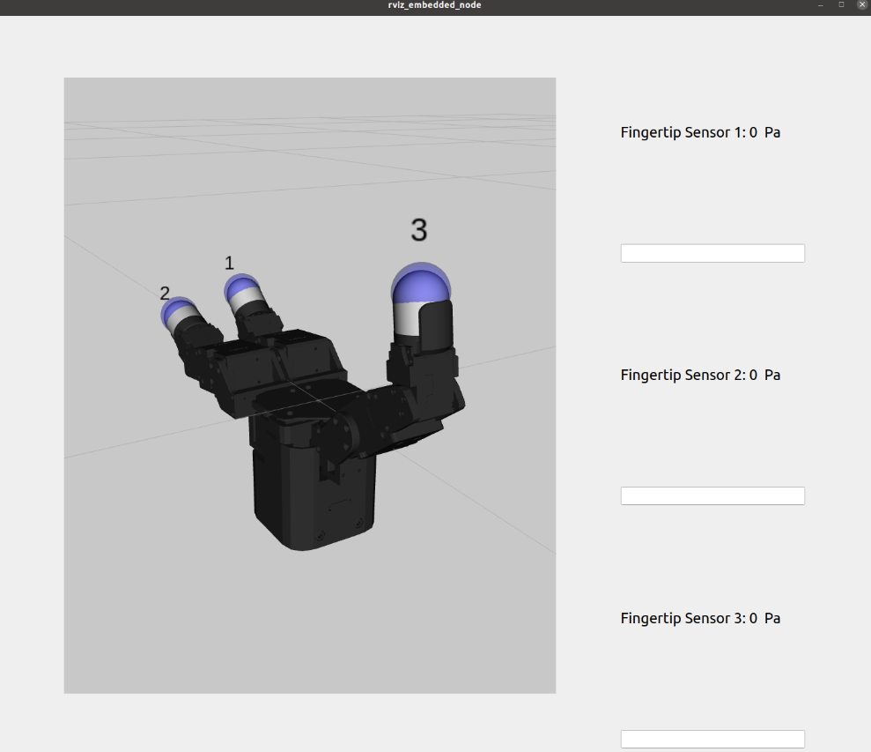

**3.2.2 Control with GUI**

This program makes Allegro Hand controlled more easily by pressing button on GUI.

Please follow the instructions:

1. Select Num of hand poses (3-finger: 14, 4-finger: 13)

텍스트, 스크린샷, 소프트웨어, 번호이(가) 표시된 사진

AI가 생성한 콘텐츠는 부정확할 수 있습니다.

1. Select poses sequentially.

텍스트, 스크린샷, 소프트웨어, 번호이(가) 표시된 사진

AI가 생성한 콘텐츠는 부정확할 수 있습니다.

* **3-finger** : home - grasp_1 – home – grasp_2 – home – grasp_3 – forcechange – forcereset – home – sphere – grasp_3 – forcechange – forcereset – sphere.
* **4-finger** : home – pinch_it – home – pinch_mt – home – grasp_3 – forcechange – home – forcereset – grasp_4 – forcechange – home – forcereset.

**Note:** If you make a mistake, please press the Refresh button and start again from Step 1.

1. Select Repeat time (1 ~ 2000) and press *start* Button.

텍스트, 스크린샷, 소프트웨어, 번호이(가) 표시된 사진

AI가 생성한 콘텐츠는 부정확할 수 있습니다.

The hand will sequentially perform the demo poses for the specified number of repetitions.